The accompanying figure compares two scenarios from the Trottier data: a conventional, Net-Zero-by-2050 (NZ50) pathway and an accelerated, Net-Zero-by-2045 (NZ45) pathway. The results suggest that while transport and industry benefit from increased DAC deployment, other sectors like energy production, fugitive emissions, and particularly electricity are more affected under accelerated decarbonization roadmaps. These sectors – significant contributors to economywide decarbonization – may require higher emissions allowances in an NZ45 scenario to meet the tighter constraints of a more ambitious energy transition. This underscores that when DAC is available, sectors may postpone mitigation by leaning on future carbon removals to compensate for present-day emissions, highlighting a broader risk: technological reliance on DAC may reinforce the status quo and existing energy system patterns, making marginal, gradual, and less disruptive adjustments more attractive to stakeholders than transformative shifts.

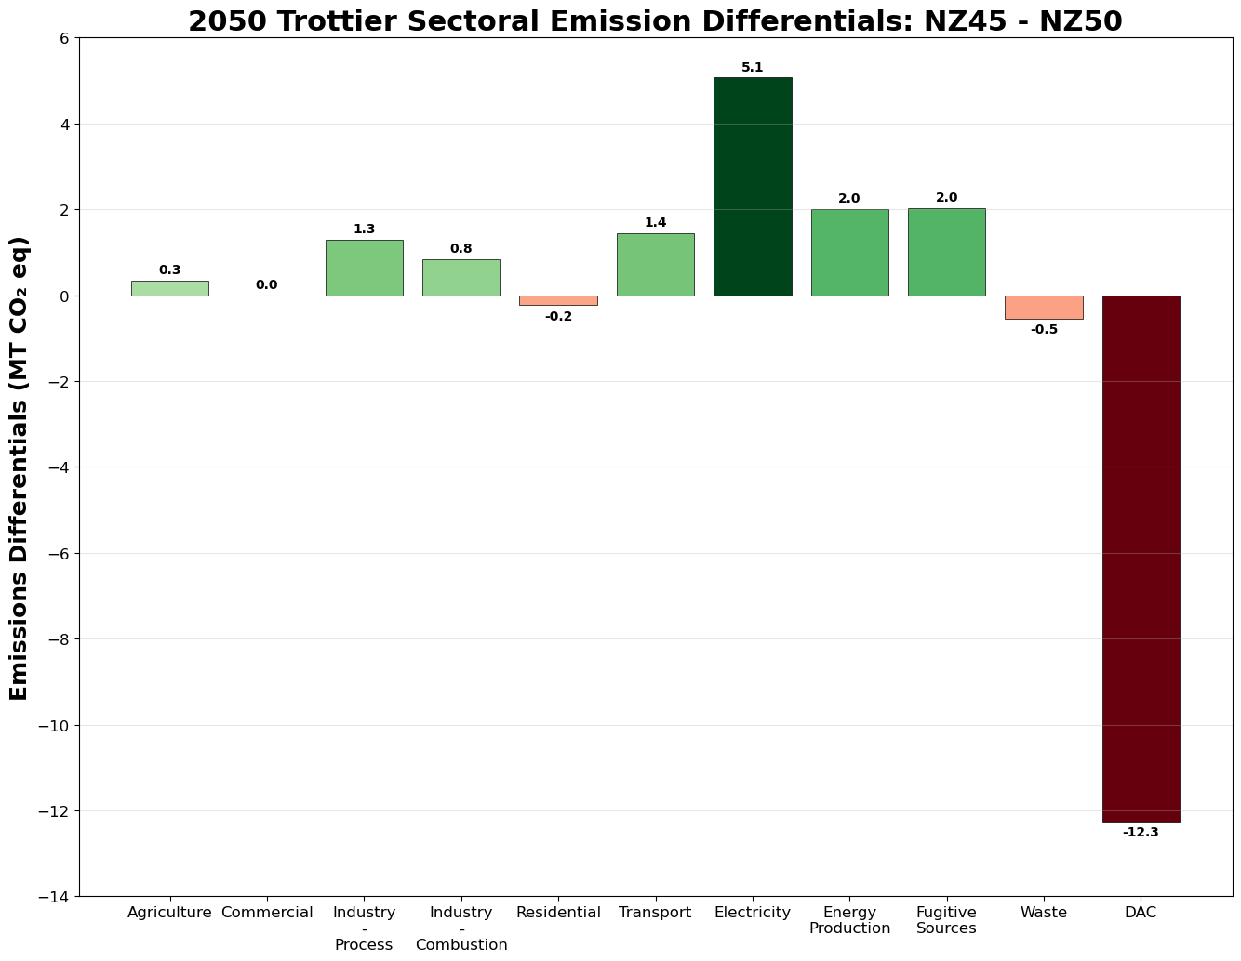
Note: In this data, BECCS implementation is incorporated under the ‘electricity’ and ‘industry – combustion’ sectors. The differentials between the NZ45 and NZ50 emissions of those sectors in the year 2050 are presented in the graph above.

